# Guest Information 2025

**Welcome on-board Duke No3.**

We are once again looking forward to welcoming guest to this year’s season on board Duke No3. 2024 was a great season and everyone on board seemed to have a great time. For those cruising with us for your first time a holiday on Duke No3 this will probably be like nothing you have experienced before as our previous guests know only too well with canal hotel holidays; things don’t always go according to plan. Somehow, time moves to a different rhythm and the past feels closer which is wonderful (and sometimes a little frustrating when we are so used to modern communication systems). Accessing the normal day to day facilities or services are often beyond our reach such as mobile phone coverage or even a local shop. We don’t cruise very fast or far but the pace we take will ensure you remain relaxed throughout your stay taking in your surroundings and even learning about the canal history and heritage. This is your holiday so you are welcome to do as much or as little as you like. You are welcome to assist with the locks and swing/lift bridges and if you like you can also take control of Duke No3 at the helm; there will always be a crew member close by to assist as required. We guarantee you will enjoy your time on board with us and this is supported by the fact that the majority of our guests are returning guests. Cruising the canals takes longer than you may expect but we will take good care of you and make sure you experience the hidden wonders and heritage of the inland waters. Great memories and friendships will be made.

**Starting Point**

You will find attached a map giving our approximate mooring location and we will endeavour to be as close to this point as possible. However, mooring locations can be affected by other boats and conditions at the time of our arrival, therefore we will call or email you when we arrive at our mooring point, usually the evening before your cruise starts if these are considerably different. If you are unable to provide us with a UK phone number then please try to call us on 07376 471154 or email us on info@hotel-narrowboats.co.uk to confirm our location. Below is a picture of Duke No3 so you know what to look out for.

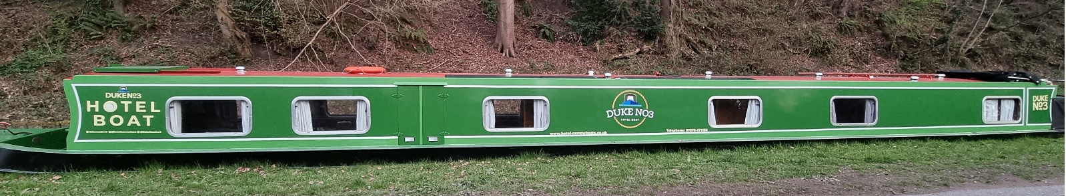

*Duke No3*

**Transport**

**Arriving by public transport:** The map gives details of the nearest railway station and is normally very close, however if this isn’t the case then the simplest solution is to pick up a taxi there. The map should enable the taxi-driver to bring you close to the boats and if we are not at the exact location, we will have let you known so you can give this information to the taxi driver. Failing that, we should not be too far away. Don’t be afraid to ask other boaters if they know where the hotel boat is moored up as they will usually have noticed us.

**Arriving by car**: [www.parkopedia.co.uk](http://www.parkopedia.co.uk) gives up-to date information about car parks in most regions including costs, locations and whether the facilities are long or short stay. Some guests prefer to drop their luggage off with us and then drive to the end location of the cruise and park there; catch a train, bus or taxi back, this way the car is then waiting at the end of the cruise.

**Taxi:** The map enclosed also gives the nearest postcode to where we will be moored, this can be given to your taxi driver. If there is not a ‘taxi rank’ at the station we have included local taxi numbers for your convenience.

**Arrival & Departure**

**Embarking:** Your cabin will be ready for you from **16:30hrs** and refreshments will be on hand for your arrival. There is time for you to settle into your cabin and have a rest or become familiar with the boat, meet the crew and other guests or just relax. We invite guests to join us in the lounge at **18:00hrs** for welcome drinks which will be followed by an important safety/information chat.Dinner will be served soon after. We spend the first night on board at these moorings (occasionally we may move); if your arrival is delayed, please let us know and we can make arrangements for you (and save you some dinner).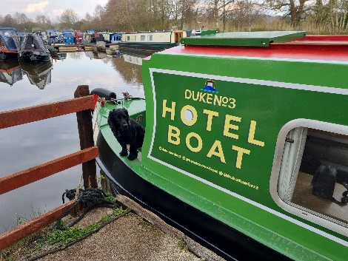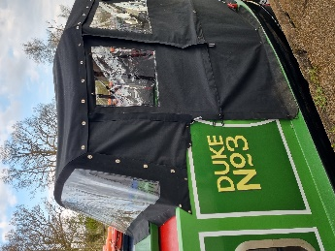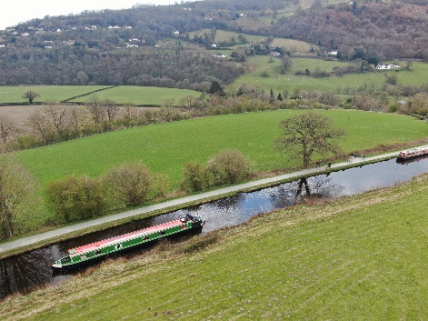 Luggage can be dropped off earlier if you wish to explore the area. There is usually someone around cleaning and preparing the boat, however if there isn’t then leave your bags in the front of Duke No3, we are never far away.

**Disembarking:** At the end of the cruise, you are kindly requested to arrange your departure before **10:30hrs** (after breakfast on the final morning) as we have lots of cleaning, shopping and laundry to attend to. We can help with making arrangements for a taxi or assist with your luggage if the station is close by.

If required, we will happily store your luggage on your departure day if you wish to explore the local area, regrettably we are only able to store luggage for this day as new guests often arrive soon after.

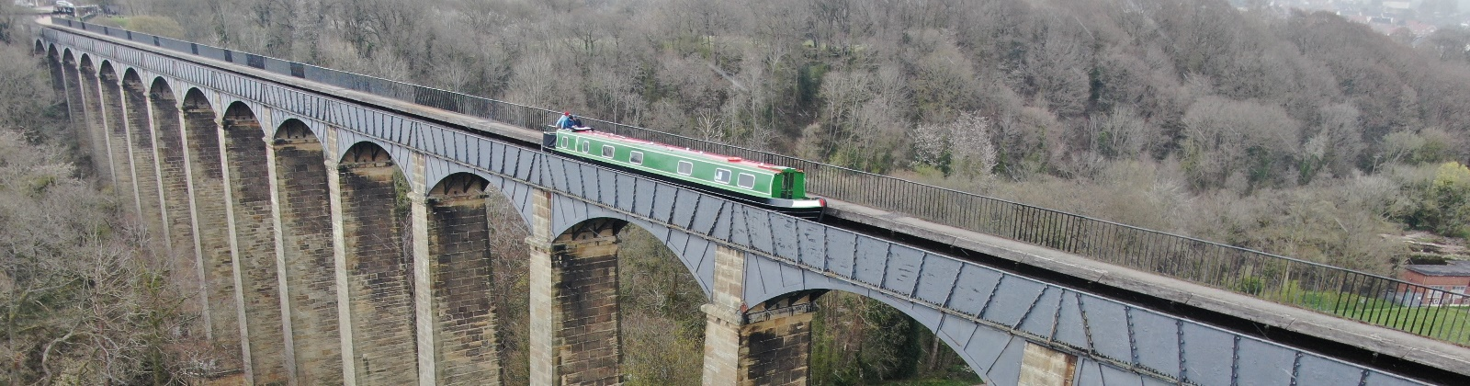

*Duke No3 crossing the Pontcysyllte aqueduct*

**What to bring?**

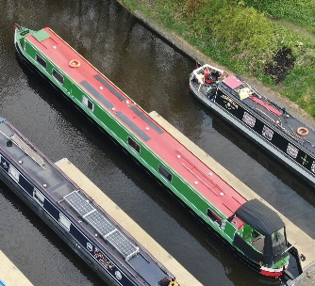Hotel boat holidays are very informal and space is extremely limited, so no need for a huge wardrobe. For on board, we strongly recommend soft shoes with a non-slip tread. For your safety and for the sake of our paintwork, no high heels please. Walking shoes or boots are a must if you intend to explore the towpaths and surrounding areas. You will need a warm fleece or jacket for chillier days and evenings (even in the summer!), a waterproof jacket, trousers and hat are strongly recommended but remember a sun hat for those hotter days. Blankets are also available for those chillier days in the well deck or sitting on the towpath.

Space is extremely limited on our boat but your cabin does have some hanging space for clothes and draws for storage. A single soft case or holdall will be much easier to stow away in your cabin than a hard bag and we cannot accommodate large suitcases. Cabins have a small torch for your use, but you may wish to bring a more powerful one if you intend to be off the boat in the evenings as the tow-paths can be very dark in the Spring and Autumn.

**Guests travelling from abroad**

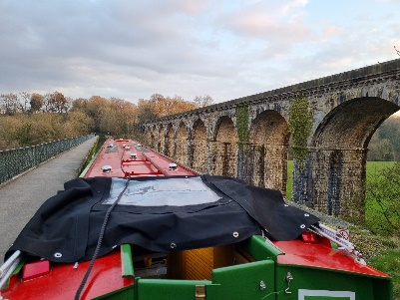

We respectfully request that you only bring enough luggage for your cruise as we don’t have sufficient space on the boats for surplus cases (we really don’t), so please make arrangements with family, friends or your hotel to look after your suitcases.

**Facilities on board**

* **Cabins** - All guest cabins are compact, en-suite and comfortable. Each cabin is equipped with hangers, torch, storage and reading light. The en-suite has a WC, basin, mirror and shower – also compact but fully functional.
* **Power** - Each cabin has a 240v socket (UK 3 pin socket) for you to charge any electricals you may have with you. Depending on power usage will depend availability, however, Duke No3 has a good bank of batteries and solar panels so we don’t foresee any power issues. We have a small hairdryer on board for guests to use if required but this can only be used once the engine is running due to its high-power consumption.
* **CPAP** - If our guests specifically need an electricity supply at night for medical reasons (such as CPAP machines) then we may have to limit/reduce power elsewhere. Battery CPAP machines would be preferable. We can not guarantee power throughout the night.
* **Bar** - We are licensed to serve alcohol and we have a small bar on board. All stocked drinks within the bar are inclusive and can be enjoyed anytime. We stock Vodka, Gin, Scotch, Bacardi, larger, Bitter, Cider, Red/White Wine and a selection of mixers. If there is a specific request for any drinks then we will do our best to source, these will be at your cost so quantity should be provided as you will be expected to pay for the full purchase, we will confirm before making the purchase, of course you can bring your own – We don’t charge corkage.
* **Meals on board** - Meal times are all enjoyed as a group at set meal times. At breakfast we serve cereal, yoghurts, fruit juices, fruit and an option of a cooked breakfast of your choice. Lunch is a light option such as quiche served with a salad selection and fresh fruit. Dinner is 4 courses with house wine and Port. Tea and coffee will be served with the desert/cheese board. Guests are kindly requested to complete and return the dietary requirements form so we can best prepare for your time on board.
* **Wi-fi** - Wi-fi is available for our guests, this is subject to having a good signal.
* **Special occasions** – Please let us know if you or a member of your group is celebrating a special occasion, we will do our best to make this even more memorable.
* **Maps and books** – We have a good selection of canal focused books and plenty of maps to keep you fully informed of your journey.
* **Postcards** – Postcards are available free of charge. We can provide stamps at cost if required.
* **Games** – We have a selection of board games available for your enjoyment. If you have a suggestion of a game you’d like to see on board let us know in advance and we will see what we can do.
* **Outside Furniture** – We have patio furniture for those sunny evenings, lunch or even dinner on the towpath. For those chillier days we also have blankets on board.
* **Forgotten items** – You may have forgotten to bring something such as toothpaste or sun hats, if so, we will do our utmost (may not be immediately due to our location) to source any items you may require at your cost.

**Finally:**

Thank you for reading these notes and we hope we’ve answered any questions you may have, please contact us if you would like any more information. We look forward to welcoming you on board and will do everything we can to make this your best holiday to date. We very rarely can’t do something a guest asks which ensures that all your hopes are met whilst on board. We will see you soon.