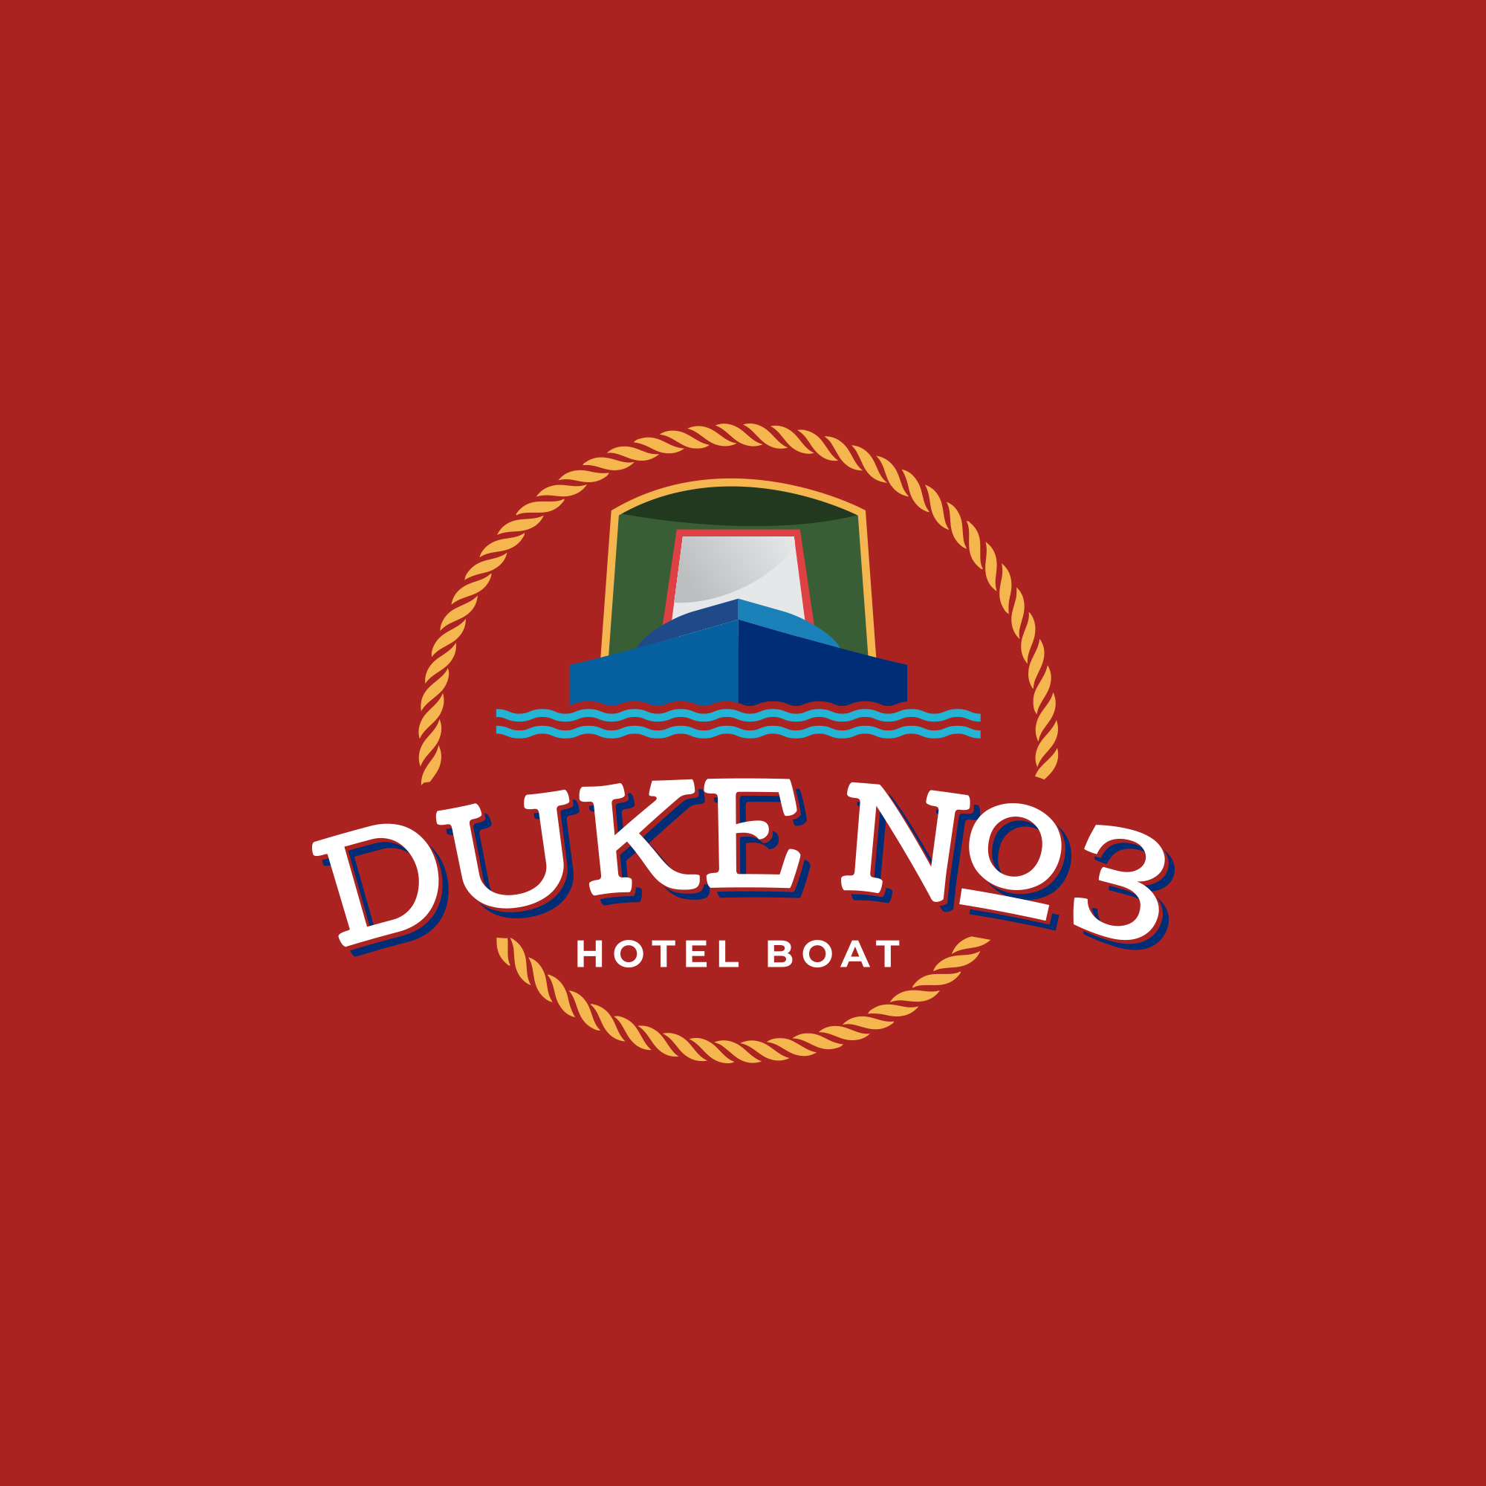**Hotel Narrowboats Ltd**

53 Penylan Road

BLACKWOOD

Gwent

NP12 0AY

Tel: 07376 471154

Email: [info@hotel-narrowboats.co.uk](mailto:info@hotel-narrowboats.co.uk)

Dear Guest,

We look forward to welcoming you on board Duke No3 very soon, in the meantime I hope this information pack finds you well. Of course if you still have any questions before arrival then please do get in touch.

2025 remains fully booked and we thank you all for trusting us with your holiday which we are sure you will thoroughly enjoy. Hotel boating remains as popular as ever, however the decline in operators is really quite sad and I’m often wondering what the future may be (I’ll be around for a while yet).

During 2025 we will continue to explore our wonderful inland waterways retuning to some of our favorite locations and new alike. Even in just a short 11 week season we’ll manage to explore and offer a variety of locations of both rivers and canals.

As you receive this arrival pack Duke No3 continues her winter maintenance program in Chirk marina. You can expect to see Henry back on board and also I’m pleased to say Taff will once again join us for the season. We will continue to offer homemade delicacies meals, cakes, biscuits and the ‘open’ bar for your enjoyment. Don’t forget to let us know of any particular dietary requirements. If you are celebrating a special occasion then you should let us know too.

Enclosed within this letter you will find information pertinent to your cruise and also some information required that we would appreciate you sending back at your convenience (one per guest). All information is held with the strictest confidence and will be destroyed on guest departure day. Please find enclosed:

1. Final invoices for your cruise – Due 8 weeks before your cruise.
2. A guest information document, which may answer some questions you may have.
3. Our proposed moorings for our pickup and drop off locations.
4. Medical and emergency contact information document (1 each).
5. Dietary requirements document (1 each).

Finally, thank you for booking to cruise with us on Duke No3. Myself, Henry and Taff look forward to welcoming you on board very soon.

Regards,

Neil.